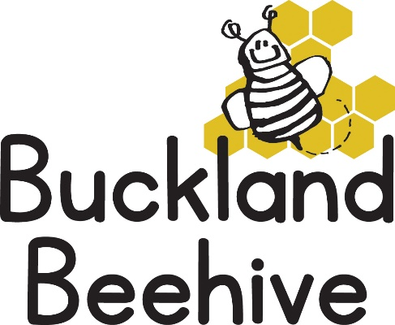
16th May 2022
Information for Parents
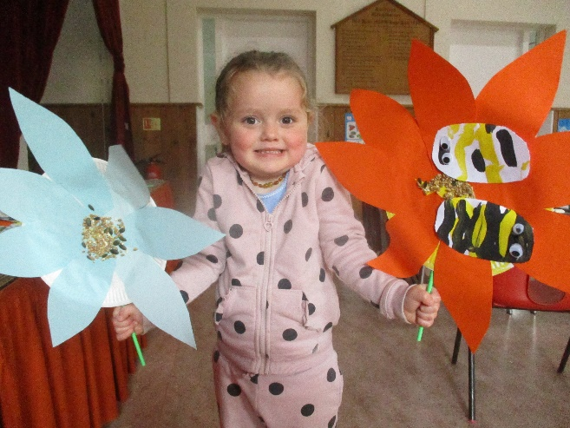
We learnt so much about bees last week, and we made some lovely flowers! The caterpillars are all now turned into chrysalis so now we wait for about a week and hopefully they will start emerging before half term.
This week we are going to “flutter and fly” like butterflies and ladybirds, we will do butterfly painting and make craft ladybirds as well as other activities.
We are slightly compromised this week, as the Drama Group are performing their production from Wednesday so we need to clear the hall nearly every day ready for them to take over. There are still lots of tickets available if you are interested.
As the sunny weather seems to be with us, can I remind you all to provide sun hats, and on sunny mornings, please put sun cream on your child before they come to Beehive, this is really helpful for us and means we can go outside knowing the children are safe.
Can we also ask that drinks bottles are named. Many of the children have the same bottle and it becomes quite confusing at lunchtime!
Thank you.

