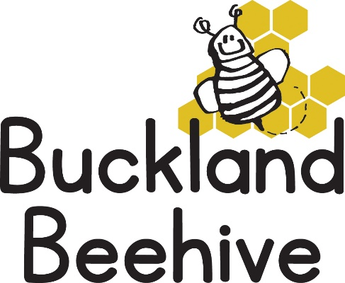
18th July 2022
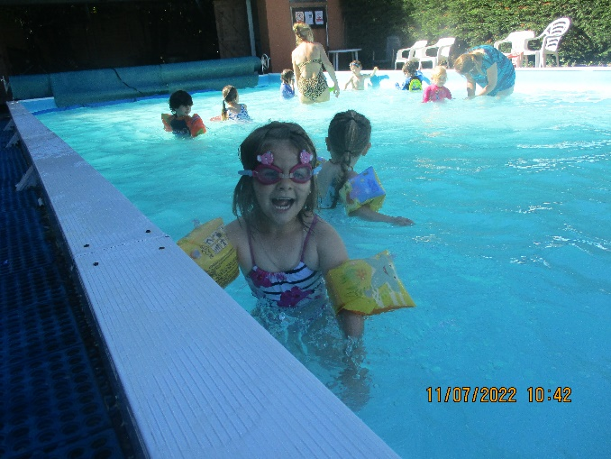
We had an amazing week! Swimming on Monday, which the children loved! Then a whole week of sunshine and lots of lion and snake craft as we talked all about wild animals in preparation for our trip to the Dartmoor Zoo on Friday.
We had a lovely time, some animals were hiding, but we managed to see the Tiger, Cheetahs, Wolves and many more. It was hot, but we were allowed to eat in the restaurant which had air conditioning and the meerkats were just outside which was great. Tara has taken a load of photos and put them on Facebook for you to see. I think we were all tired by the time we got back! It was a super treat for us all.
This week we conclude our animal theme by talking about our pets. If you have a pet you would like to bring in to show us, that would be amazing or you could bring in a photo to show us. Walter the dog will be making regular visits and we will be learning how to care for them too.
Swimming on Monday will definitely go ahead this week, we need your child’s costume, towel and buoyancy aids in a small backpack. Please remember to put sun cream on your child before preschool.
On Friday we are having a party day, we haven’t told the children yet, but we will have a bouncy castle in the hall with the bikes and cars. Try and keep it a secret otherwise they may get too excited beforehand! Bring in a packed lunch as normal and we will have some party food for snack later in the afternoon.
The leavers will be taking home their scrapbooks and a gift from preschool, so if your child is not coming on Friday, please let us know beforehand so we are prepared. Everyone is invited on Friday, even the children that are not normally booked in. If you just want to pop over for a couple of hours in the morning, that is also fine, can you please let one of us know so we have an idea of numbers.
For the children that will be returning in September, can you have a think about what sessions you would like, if you want to increase your hours or change the day, this is the best opportunity to do that before we get busy again. Some of you will now be entitled to your 15 hours free childcare, so can you let me know as soon as possible any changes you want to make. We will be changing our Thursday session to stretch until 3pm starting in September which is really good news, so all five sessions are a full day.
Also, can you save a shoebox. Our theme for September is going to be “All About Us”, and each child will have their own shoebox to decorate and fill with items that they love. I will remind you nearer the time, but don’t throw them out!!
Don’t forget to place your orders for photos, I can pass them on to Beki for her to process.
We will say a very fond farewell to our children starting school, some of them have been with us for two years! I know they will all have a great time and they are so ready for the next stage in their development.
Thank you to everyone for your continued support of Beehive, it is so appreciated. We all wish you an amazing summer, enjoy it, and return refreshed in September!
Best Wishes
Jane, Tara, Angie & Debbie

