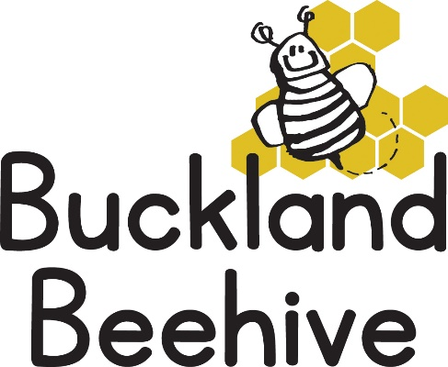
20th March 2023
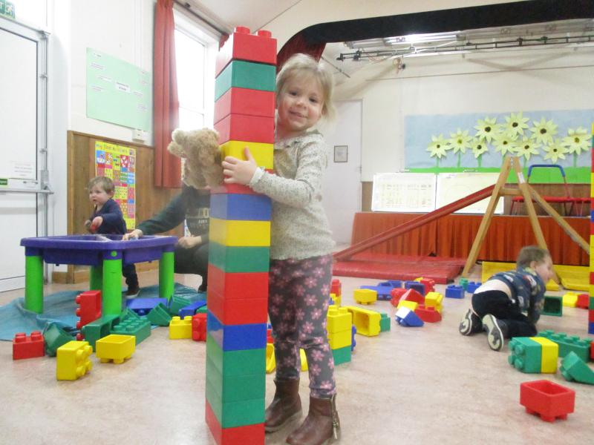
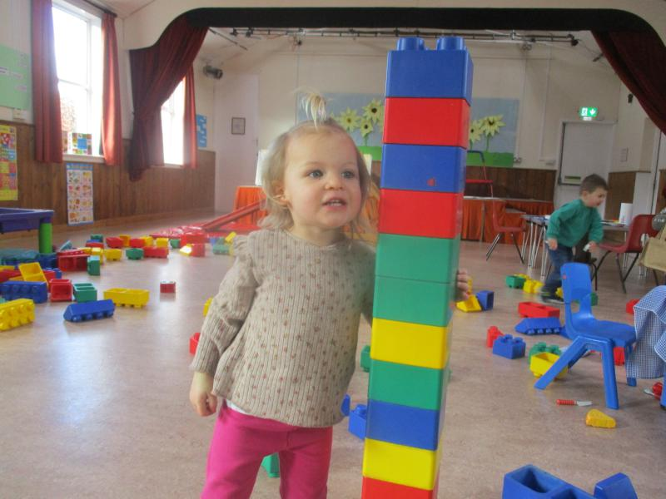
We spent last week learning about things that grow, including ourselves. They made some amazing towers out of the giant blocks, which didn’t stay up for long, they were far too much fun to knock down! We noticed our sunflowers are growing too. We hope all the mums enjoyed their paper plate creation with your own child’s comment on why you are so special.
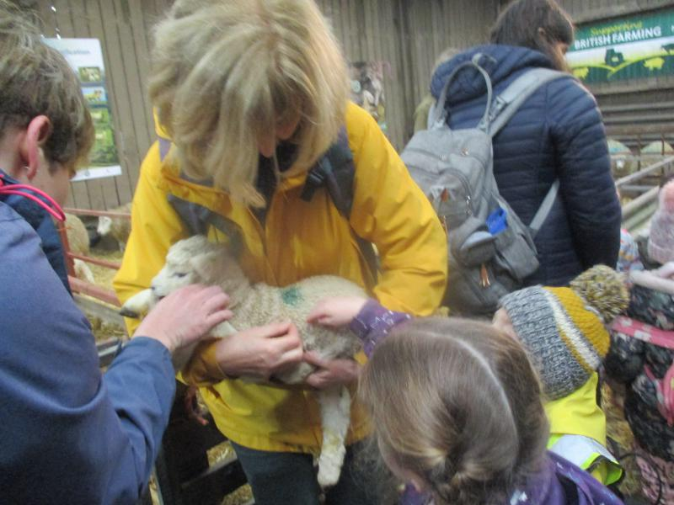
Thank you again to everyone for making the trip to lambing live so successful. What a lovely time we had, the children all seemed to enjoy the experience, as did the adults that came. All having the opportunity to snuggle the lambs and feed the ewes. A lovely trip that we will hopefully repeat again next year.
This week we are talking about the weather! And what a lovely weekend we have had, although it may not last, we will be setting up our own rain gauges outside, making suncatchers, rainmakers, having our own weather station set up and making wind streamers, so a busy week again. The phonics letter this week is letter “o”, all around the orange.

