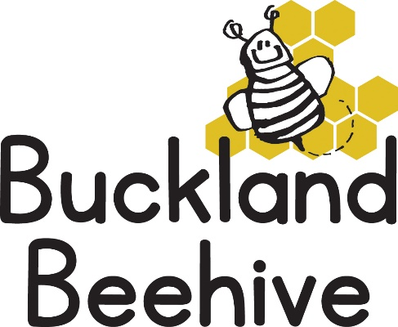

19th April 2021
Information for Parents
Welcome back! We hope you all had an amazing Easter, we have been really lucky with the weather, let’s hope the sunshine continues!
Our theme this half term will be Minibeasts, starting with “What are Minibeasts?”. We will be looking at all kinds of bugs and tiny creatures, I have some caterpillars, that we hope to watch transform into butterflies, and the tadpoles have not quite made their change either, which is good as the children will be able to hopefully witness them grow into little froglets.
We will be making bugs and bug homes out of junk and we have set up a bug assault course so the children can creep and crawl like insects through the undergrowth. We are also continuing with our phonics
With the weather in mind, please can you continue to send in your child’s named wellies, we will be going on a number of bug hunts over the next few weeks so they will be needed.
We welcome Darcie Lowe to Beehive, she has recently moved to the village with her family and are very excited that she will be joining us this term.
We are also opening the Toddler Group on a Thursday morning, from 9.30am until 11.30am. Parents are required to wear masks and wash hands on arrival. We will have a free flow session whereby the front doors will be open so the children and adults have access to outside at all times. All members of staff will continue to take Lateral Flow tests weekly.
Don’t forget, you can talk to us about your child’s progress anytime or contact Jane via email if you have any questions or concerns.
Many Thanks

