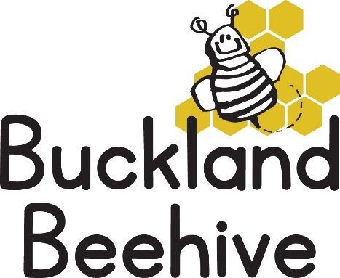

Privacy Notice
Introduction
We are committed to ensuring that any personal data we hold about you and your child is protected in accordance with data protection laws and is in line with your expectations.
This privacy notice explains what personal data we collect, why we collect it, how we use it and how we protect it.
What personal data do we collect?
Personal details that we collect about your child include:
- Your child’s name, date of birth, address, health and medical needs, developmental needs and any special education needs.
- Where applicable we will obtain child protection plans from social care and health care plans from health professionals.
- We will also ask for information about who has parental responsibility for your child and any court orders pertaining to your child.
Personal details that we collect about you include:
- Your name, address, email address, phone number (including work numbers), emergency contact details and family details if necessary. This information is collected directly in the Registration form.
- If you apply for 30 hours funded childcare we will also collect your National Insurance number or unique taxpayer reference (UTR) if you are self-employed.
- We may also collect information regarding benefits and family credits that you are in receipt of.
Why we collect this information and the legal basis for handling your data
We use personal data about you and your child in order to provide childcare services and fulfil the contractual arrangement you have entered into. This includes using your data to:
- Contact you in case of an emergency
- To support your child’s wellbeing and development
- To manage any special educational, health or medical needs of your child whilst at the Beehive
- To carry out regular assessment of your child’s progress and to identify any areas of concern
- To process your claim for up to 30 hours funded childcare if applicable
- To keep you updated with information about the service we provide.
- We will record your child’s activities for their individual learning record. This will include photographs. You can withdraw your consent at any time, for images taken by confirming in writing.
We have a legal obligation to process safeguarding related data about your child should we have concerns about their welfare. We also have a legal obligation to transfer records and certain information about your child to the school that your child will be attending, i.e. Transition Document.
Who we share your data with
In order for us to deliver childcare services we will also share your data as required with the following:
- Ofsted – during an inspection or following a complaint about our service
- The Local Authority (When you claim 30 hours funded childcare)
- The School that your child will be attending (as above)
We will also share your data if:
- We are legally required to do so by law or by a court
- We need to protect your child, for example by sharing information with social care or the police.
We will never share your data with any other organisation to use for their own purposes.

How do we protect your data?
We protect unauthorised access to your personal data and prevent it from being lost, accidently destroyed, misused or disclosed by keeping it locked in a secure filing cabinet in the locked preschool store room at the Village Hall.
Some personal data including email and home addresses are kept on the preschool laptop, which is permanently at the home of Jane Beard and password protected.
How long do we retain your data?
We retain your child’s personal data for up to 3 years after your child no longer uses the Beehive. Medication records and accident records are kept for longer according to legal requirements. Your child’s learning and development records are maintained by the staff at the Beehive and handed to you when your child leaves.
In some instances (child protection or other support service referrals) we are obliged to keep your data for longer if it is necessary to comply with legal requirements.
Your rights with respect to your data
You have the right to:
- Request access, amend or correct you child’s personal data
- Request that we delete or stop processing your child’s personal data.
- Request that we transfer your personal data and your child’s to another person.
If you wish to exercise any of these rights at any time or if you have any questions, comments or concerns about this privacy notice, or how we handle your data please contact Jane Beard. If you continue to have concerns you have the right to complain to the Information Commissioner Office (ICO) at Information Commissioner’s Office, Wycliffe House, Wilmslow, Cheshire, SK9 5AF or ico.org.uk/
We will keep this notice under regular review, you will be notified of any changes where appropriate.

