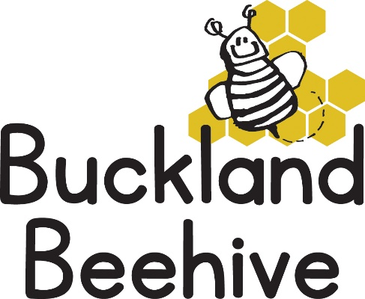
14th June 2021
Information for Parents
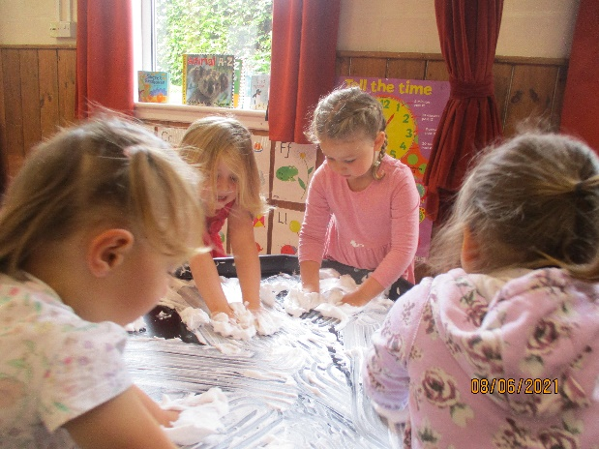
We had a fun week learning all about Oceans, the children made some great Ocean pictures which we have put on our display board, they also had fun with shaving foam, (there are some good pictures on the website), a very messy and tactile substance!
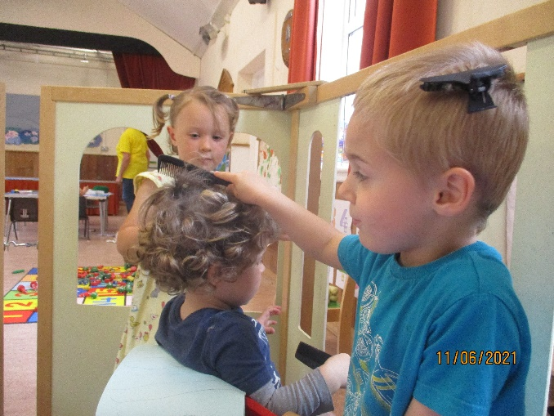
We also planted our beans, but we noticed that the slugs have attacked them. If any of you have some organic solutions to getting rid of them it would be much appreciated. We are really looking forward to being able to pick our strawberries, there are loads of fruit waiting to ripen.
We also set up a hairdresser shop, with a load of utensils that Tara found in the Pound Shop. The children loved it and both Tara and Angie were their guinea pigs!

This week we are talking all about the creatures that live in the sea. Craft will be a paper plate octopus, and a flying fish. Debbie will bring in some seaweed for us to look at and we will attempt to make our own rock pools in the water trough.
Although it looks like the weather is going to be hot on Monday, we are unable to use the school pool just yet, as I need to confirm that we are able to use the changing rooms at the poolside, also we need all consent forms to be returned before we can take the children. We have decided that we will take the children for a walk to the Meadow and have a snack picnic instead.
Please remember sunhats and could you put sun cream on your child before they come to preschool, thank you.
The hall phone is now working again, we are testing it daily at the moment just to make sure but if you experience any problems, please let us know as soon as possible.

Many Thanks

