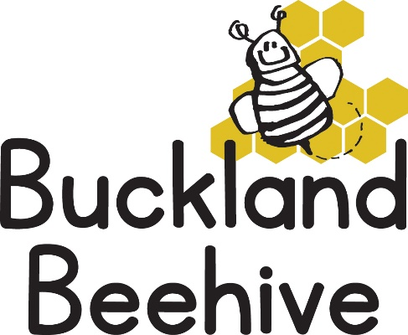

26th April 2021
Information for Parents
We were so lucky with the weather last week and spent loads of time outside. We put out the water play tray which they all loved!
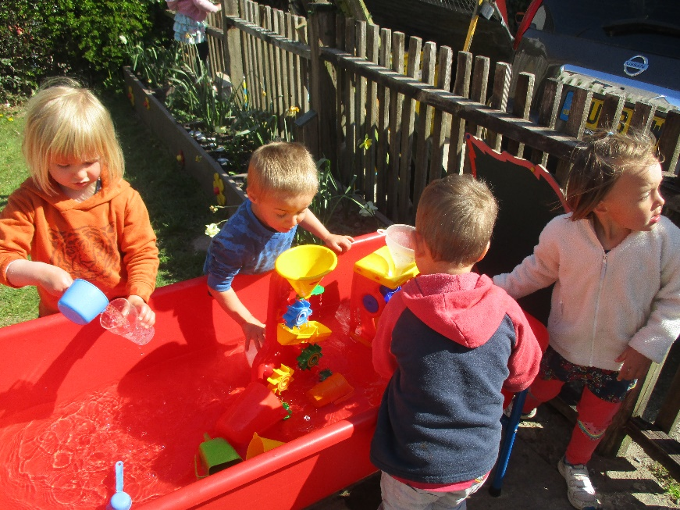
The children also made some amazing bugs and butterflies out of junk to go with our theme. We hunted outside for live specimens and Drake found an amazing worm!
This week we will be talking about bugs that Creep & Crawl. Caterpillars, worms, beetles and centipedes. We will make snails and caterpillar craft and we will be talking about the life cycle of a butterfly. Our live caterpillars continue to grow, they will be forming a chrysalis soon, which is always an exciting time.
Our adult led activities will be concentrating on numbers this week, and we will continue with our phonics. Later in the week we will be making snails out of salt dough and maybe some jelly bugs! So, we have a busy week ahead.
Please can we remind you to collect your children promptly at 3pm. Tara, Angie and myself need to get to school to collect our own children so, with this in mind collection can be anytime after 2.45pm just so we are not rushing your children out the door.
Also, on Friday, Tara takes her son to school before driving from Tavistock to Beehive, she aims to arrive before 9am to open up but this is dependant on the traffic at this busy time of the morning. Angie and myself drop children at St. Andrews before Beehive, so if you arrive before us, please be patient, we will open up as soon as we are able.
As the weather is starting to warm up, can we also remind you that staff at Beehive, for various reasons, are not allowed to administer sun cream, please can you make sure you cover your child before the session, as well as providing a sun hat. During the hottest part of the day, we can always use our environmental area which is well shaded, but if we know the children have sun cream on it means we can be flexible.
Many Thanks

