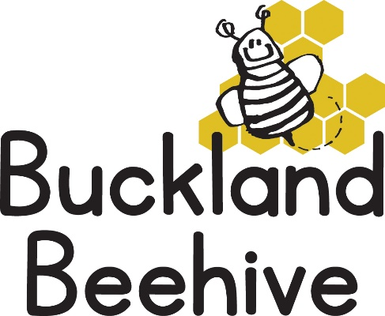
8th November 2021
Information for Parents
Great Autumn crafts last week leaf prints with paint and with clay, some of the children even made hedgehogs out of clay, which were brilliant and fitted in with our talk about hibernation. And if you had fireworks over the weekend we made some firework pictures and rockets. So, a busy craft week!
As the weather continues to be dry but getting increasingly cold, it is fitting that this week we will be talking about Winter, snow and ice! So, a number of craft activities lined up this week as well.
We will be experimenting with ice and we have a tray full of polystyrene balls and snowy animals (no doubt the hall will be covered in these balls throughout the week!!) We are also making bird feeders which you will be able to hang in your garden.
We have some new pets! Over half term I bought two new goldfish to replace Raindrop and Sunshine that both sadly died earlier this year, they were both 4 years old, which I am told is quite a good age for a goldfish.
The children decided on Friday that they should be called “Bob” and “Skye” (Paw Patrol), much to our amusement, so that is what they will be! We continue to look after Bee the Guinea pig, even though she has a tumour she continues to do well and the children love feeding her each morning.
This week I have included in the book bags a small form for you all to confirm your contact details, please complete and return as soon as you can.
Just a reminder, if you should need to contact us at the hall the number is 0560 3865484 If we don’t pick up it may be we are outside or out for a walk so please keep trying.
Could you also send your child in with some waterproofs, if you have them, if the weather changes it allows us to continue to go outside knowing the children have suitable clothing on.
On Saturday 13th November there is a Coffee morning in the hall from 10am until 12 noon, there are various stalls selling goods so if you are interested do go along and give your support.
Many Thanks

