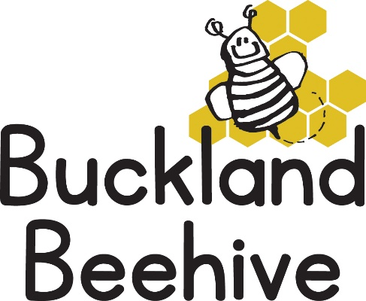
22nd February 2021
Information for Parents
Welcome back to Beehive, we hope you all had a relaxing week even though the weather was a bit wet! Spring does seem to be in the air, the birds are returning and some daffodils have already opened, we are eagerly waiting for the daffodils that we planted two years ago to open up and brighten our garden at the hall and over the next few weeks the children will be deciding what vegetables we need to plant this year and we continue to hope our strawberry plants will keep producing fruit.
Our theme this term will be “Fairy Tales” and we start off with The Gingerbread Man. This gives us an excuse to do some cooking this week making our own Gingerbread men and women, we will also be making some hand puppets, practising our Phonics and adding to our display board.
Please continue to bring in wellies and wet weather gear, as the gardens are still very muddy. We will welcome Florence (Flossy) to Beehive on Tuesday, she has recently moved to Buckland with her family and is very eager to join us! and we celebrate my birthday as well so another excuse for cake!
As we haven’t been able to update you all on your child’s developmental progress over the last few months, we have decided to write a short report in your child’s yellow book, updating you on their abilities, achievements and noting any areas that we are working on to give you some idea on how they are doing. If you have any concerns or questions please use the yellow book as it is not always convenient or private when you drop off or collect your child to have a discussion and if you want to make an arrangement to speak with your child’s keyworker please let us know.

Many Thanks

