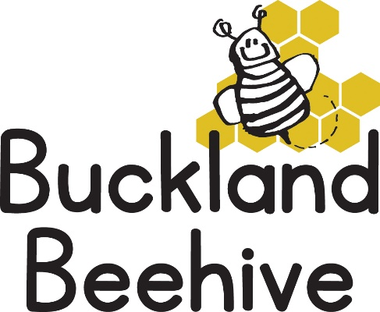
9th November 2020
Information for Parents
The children were really interested in Planet Earth, they made some great Earth plates, and really got stuck in to recycling and saving our Planet! We also made a good start on our phonics as they all joined in the little rhymes with actions.
We continue our Space theme this week by looking at the Sun. Let’s hope we have some sunny days as we will be talking about our shadows, light and dark, heat and cold, including lots of experiments with ice. We erected our igloo last week which was a great success as the children took torches inside and made light patterns.
We have at last managed to get a result negotiating with the other user groups, and we now can have a full day on Monday, Tuesday Wednesday and a Friday, 9am until 3pm. The Art Group on a Thursday refused to entertain any changes to their sessions. At the moment no other groups are using the hall so we can continue in the main room, when they start returning, we will finish our session on a Monday and Wednesday in the Room at the side of the hall. This enables us to carry on until 3pm alongside some groups which will use the main hall at the same time.
We are really pleased to be able to offer these extended afternoons and if you are interested in booking your child in please let Jane know as soon as possible so we can start the sessions.
Many Thanks

