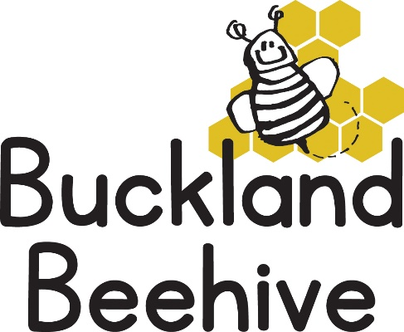
4th May 2021
Information for Parents
The children made some fabulous snails and caterpillars last week so we have displayed them on our noticeboard, we will continue to add to our minibeast picture and I will take a photo for you all when we have completed it.
We made some jelly bugs which they enjoyed eating on Friday, and everyone is becoming quite expert at hunting for minibeasts in the garden. This is something that you can encourage at home and see what you can find.
This week we are talking about “Hum & Buzz”, so bees are going to be our main topic. I have some honeycomb for us to try and we will be having toast and honey for snack as well as making sunflowers for our display and handprint bees!
Tara has an interesting activity with toothbrushes and soapy water, Angie will be working with numbers and Debbie will continue with rhyming and phonics.
Let’s hope the weather warms up soon as I have asked Sarah Lakey if we could start our swimming sessions after half term, I will let you know if this is going to be possible. I also would like to start taking our school starters down to Foundation once a week, but this is obviously dependant on the relaxation of the covid restrictions. Again, I will keep you posted.
Many Thanks

