19th July 2021
Information for Parents
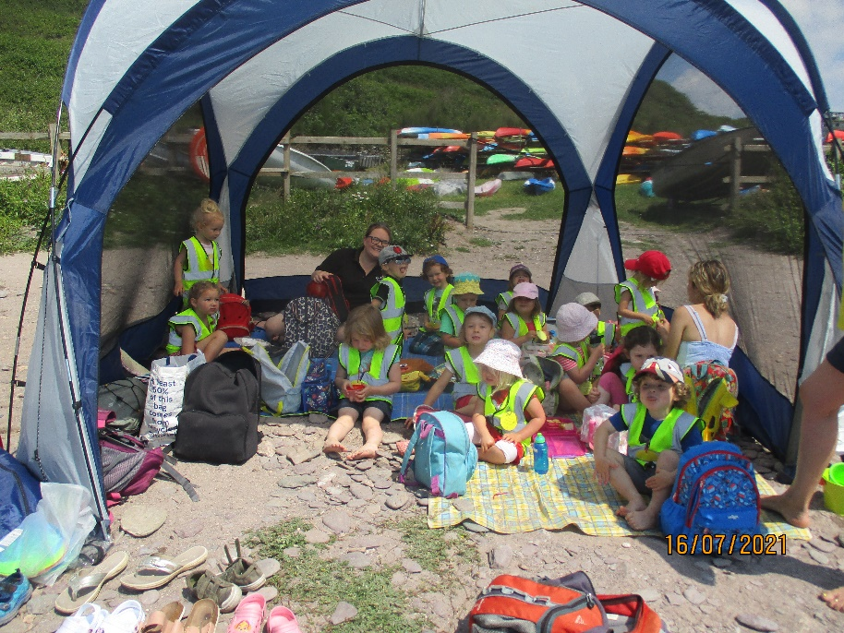
We had an amazing trip to Wembury on Friday! The children, staff and volunteer parents all had a fabulous day. Thank you to Christina, Bethany, Claire and Chelsea who all helped make it a memorable day as well as to Emma who lent us this fabulous tent which was not too difficult to erect!!
I have downloaded more pictures of the trip onto our website and Tara has put loads on Facebook. Please take time to have a look at your wonderful children, they were all beautifully behaved, I was very proud of them all.
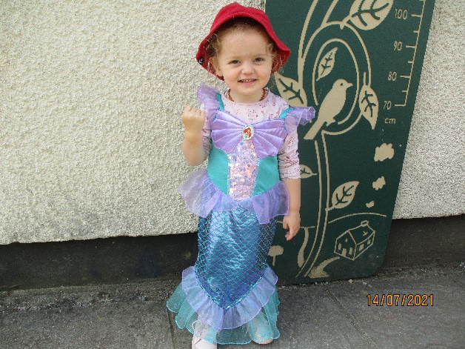
We also had a fun week dressing like pirates and mermaids, we made some great treasure maps and telescopes, and even had a treasure hunt of our own with a chocolate surprise at the end!

In our last week we will be talking about the Seaside and making yellow collages, Sports day on Tuesday, with no parents unfortunately, but again we will send out photos for you to see. Then Friday is our last day of the Summer Term. All belongings will need to go home as the hall will be deep cleaned whilst we are away ready for our return on Tuesday 7th of September. (make a note in your diary)
Our OFSTED visit went well, I will email the report to you all once it has been released and made public, which should be within the next couple of weeks.
Thank you all for your continued support this term, for the parents of the children that will be returning in September, if you need to revise which days your children attend, or would like to increase days etc. Please let me know as soon as you can so I can prepare during the holidays. And for those parents and children that are leaving us, we hope they enjoy their new schools, we wish you Good luck you will be missed by us all.
This is our display board this term with jellyfish and a turtle and an amazing octopus, all having to come down now ready for the Summer. Thought you may like to see the work the children have done this term.
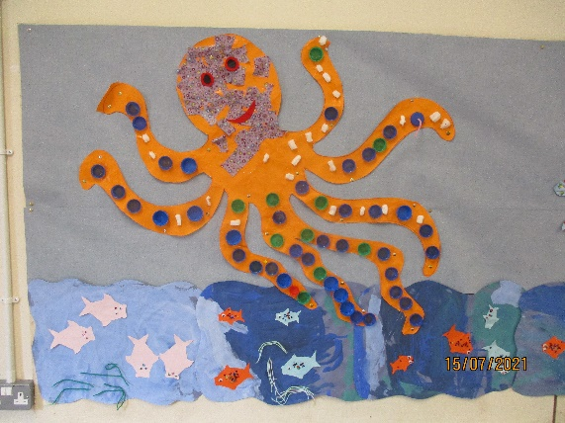
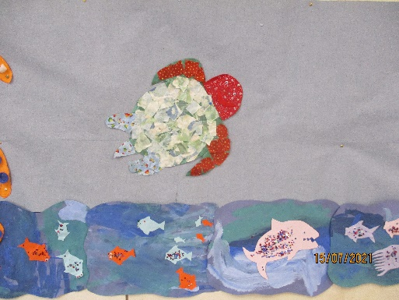
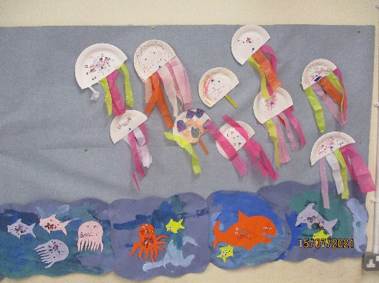
Many Thanks from the Team at Beehive
Jane, Tara, Angie & Debbie

