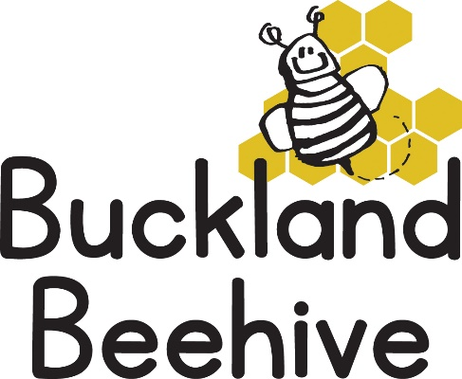
13th March 2023
The children had the chance to handle the chicks last week, it was amazing to see how quickly they grew and started to get their adult wing feathers, some starting to fly around the tray we had them in.
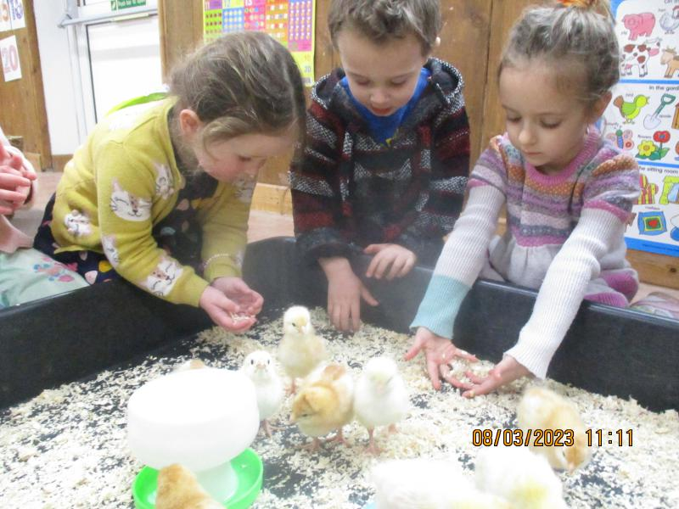
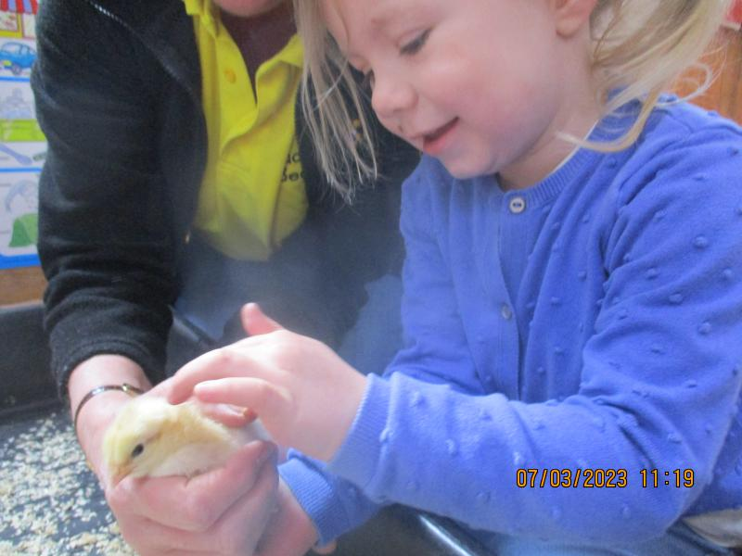
They were collected on Friday and will be placed in a small farm in the Midland area. A truly lovely experience for us all.

We planted our sunflower seeds and made some fabulous sunflowers for our theme board which looks great.
This week after learning about planting, we will be looking at things that grow, from people to plants, and even plants that we grow for us to eat! Learning about healthy foods, and if the weather permits we will plant our carrots which we failed to do last week. Our phonic letter this week is “g” down the girls face, down her hair and give her a curl. Finishing the week by making something special for super mums!
Thank you again for raising such an amazing amount of sponsorship which enables us to choose £576 worth of books for Beehive! A tremendous effort.
On Friday we have our trip to Lambing Live, I will send out further details to everyone that is coming with us. For the children that are normally booked in on a Friday, just arrive at normal time.
Many Thanks

