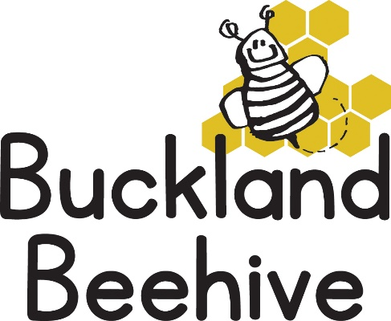

1st June 2020
Information for Parents
I thought I would send out this newsletter early so that every one that is returning to preschool on Monday is well prepared and it will give you all an opportunity to contact me over the weekend if you have any questions.
Hurray, we are finally able to open our doors again! After my letter to you all we will start with 10 children returning on the 1st June, which is perfect for our initial “bubble” of children. Luckily this number of children is below the Government guidelines of 15 per “bubble” so the children will be able to roam freely around the hall and it should be less restrictive than other larger settings.
Tara, Angie, Debbie and I will need to completely disinfect the equipment, toys and clean the hall at the end of every session ready for the next day. Because of this there will be less resources available each day, but we will do our best to entertain and stimulate the children.
The most important thing is that they learn to socialise again, so we will be very relaxed and provide a gentle atmosphere where they can once again play with their friends and familiarise themselves with the preschool routine.
The structure of the session will be more open, we will not be doing Show and Tell so can you please not bring any toys from home. Once all the children have arrived, we will open the front doors and have free play between the hall and outside in the front garden. We will have snack time and lunchtime, weather permitting outside. During the afternoon sessions we will migrate to the back garden which is shaded by the Beech trees, so we can spend as much time as possible outside.

Please remember to put sun cream on your child prior to arriving, and provide them with a small bag with a change of clothes including a sun hat. The children will NOT be allowed in the garden without a hat. Don’t forget to send them with their lunch boxes!
You may want to prepare your child for the drop off scenario, as NO parents are allowed into the hall at any time. We will open the front door and welcome the children in one at a time so we can hang up their bags, wash their hands and take them into the hall to play. We will sign in your children when they arrive and when they leave. Please try and remember to social distance yourself from other parents whilst waiting outside.
You can arrive anytime after 8.45am, and at pick up time you can arrive any time after 12.30pm until 1pm, or 2.30pm until 3pm on Tuesday or Wednesday. This will hopefully help spread you out so it doesn’t become too crowded at any time. If you arrive in your car and see a number of parents waiting, please stay in your car until you consider it safe.
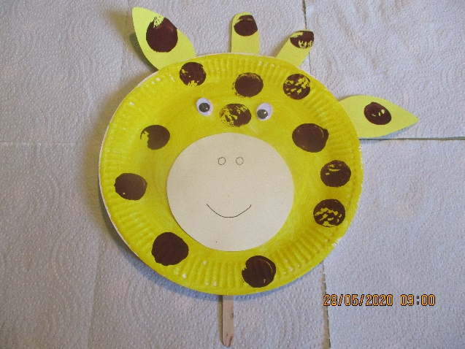
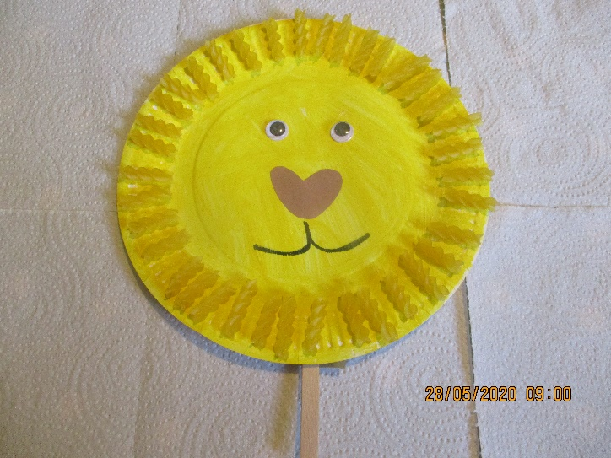
The theme this term is “Animals”, and this week we will be talking about wild animals, we will be making loads of craft! Here is a paper plate lion with his main made with fusilli pasta! And another paper plate made into a giraffe with the spots made by a cork or small round object dipped in paint.

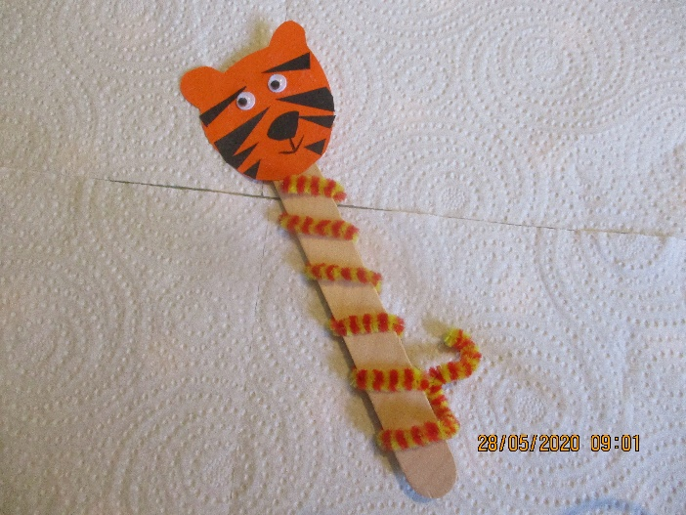
And a Tiger lolly stick with a pipe cleaner body! Paper plates are so useful and can be made into whatever animal you like!
I will restock the craft table at the Chapel for all the children that are not returning to preschool, so that you can still make any of our craft ideas at home.
We will be making dens for wild animals at preschool and we are going to try and think of animals that begin with the first four letters of the alphabet so we can make an animal frieze on our display board. We will be talking about where these animals live around our World and I am sure we will be imitating the noises they make and how they move!
I hope I have remembered everything, if not please email me and let me know! For all our children still at home we will continue to post work sheets on Facebook and you can still make your crafts, don’t forget to send us your photos, we love to see what you have made.
Thank you for your patience, and let’s hope this gradual return is a success.

Jane, Tara, Angie and Debbie

