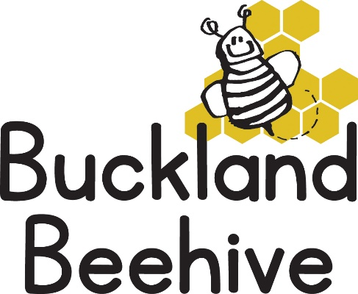
1st November 2021
Information for Parents
Welcome back! We hope you all had a good half term, even though it was very wet and blustery. We start our new half term talking about our new theme of the Seasons and the Weather.
Autumn being our first season so we will be doing lots of leaf printing on paper and in clay, and we will be making some rainmakers as well as starting to make a “Seasons” mural for our display board.
We will be talking about our Nativity. This year we will be doing a little play based on the book “Little Owl and the Star” with some songs. We will be performing on our last day of term Friday 17th December at 9.45am. I am hoping that covid restrictions will have lifted enough for parents to be able to come and watch this year, but a decision will be made nearer the time. We will also let you know what characters the children will be when we have had a chance to talk to them about it.
The DVD was such a success last year that I will try and organise Jeremy to return and film us again. After the Christmas play we will have a party lunch, so no packed lunches that day, and then an afternoon of games until home time. If your child doesn’t usually attend on a Friday please can you confirm if they will be able to take part and stay for the full session.
Toddler Group will reopen this week, so spread the word.
Please remember to send your child in with welly boots and coats
Many Thanks

