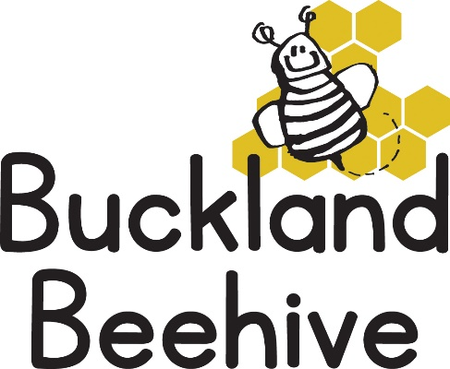
29th November 2021
Information for Parents
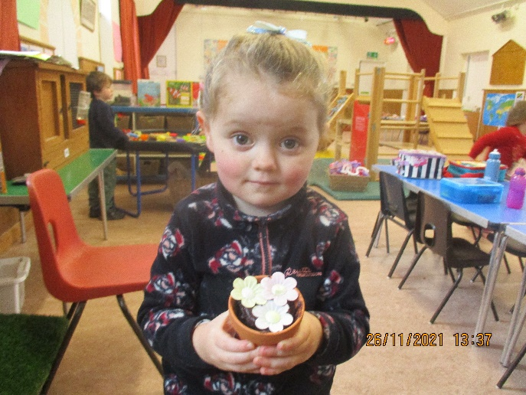
It was a bit strange talking about the Summer season when it was so cold last week!!, but we finished our theme board and it looks fabulous, the children enjoyed doing so many painted handprints for each of our trees. They also made some great rainbows, and on Friday, we were treated to a real rainbow outside during our session, which was fabulous. Some of the children also made flowerpot muffins, I hope they were as delicious as they looked.
This week we are talking about forecasting the weather, we will have a weather station set up with maps, an atlas, the globe and weather signs. We will be making television screens from junk boxes so we can make our own forecasts. And we have two birthdays to celebrate this week, Sienna and Jocelyn!
On Wednesday it is December! So, we will start to learn our Christmas songs for our Nativity. At the moment, we are hoping that you can all come and watch the show, as long as the cases of Covid don’t increase dramatically. We will make a decision nearer the time.
We plan to have the Nativity on Friday 17th December in the morning at 9.30am and it usually lasts no longer than 20 minutes. We will then carry on with the session and have a party in the afternoon. If your child doesn’t usually attend on a Friday, they are very welcome to join us for the Nativity, and then come back for the party, or they can stay for the whole session. We usually do a party lunch, and have Father Christmas arrive, but we have decided not to invite him this year as he is elderly, but he has agreed to drop of the presents like last year. If you could confirm if your child will be coming in for this day, that would be brilliant.
On Saturday 4th December, between 12 noon and 2pm, St. Andrews School have their Christmas Fayre. This year it will be held outside in the playground, (let’s hope it is not as cold as this weekend) and the Beehive have a table, we will be holding a soft toy Tombola, Guess the name of the Bunny and selling second hand children’s books. Please come and support us as we have decided to start a fundraising campaign to raise money for a minibus for preschool! Also, if anyone has any contacts, or knows someone that can do a deal on a minibus that would be great too!
So, lots of exciting things to look forward to. Please continue to send the children in with hats and gloves etc. as we do go outside every session and it is getting very cold,

Many Thanks

