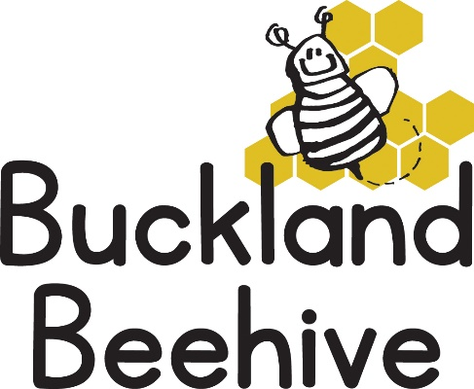
7th June 2021
Information for Parents
Welcome back! Hope you all had a super time over half term as many of you were visiting Grandparents for the first time in ages, so we are really looking forward to hearing all about it from the children. And we were lucky with the weather!
Although it has warmed up considerably, we will not be swimming this Monday. The experience has to be a really positive one for us all and this is dependant on the day being really sunny. Also, all parents with children booked in on a Monday morning will need to complete a short questionnaire on their child’s ability etc. before we can start the sessions. This will be in your child’s bookbag this week, please sign and return as soon as possible.
Our theme this term is “Oceans & Sealife”, the first week we will be finding out all about what Oceans are, making an ocean in a bottle and talking all about Ladhia, our sponsored child in Mafia, Tanzania, as she lives on an island, like us, but much smaller and her family’s livelihood depends on the ocean as her father is a fisherman.
We will continue with our Phonics and Phase 1 Letters & Sounds and Tara will have an interesting sensory activity to introduce to the children.
As the weather has improved, please can you send your child to Beehive with a sun hat and cover them in sun cream before you drop off, please, thank you.
Unless I hear otherwise, we are not able to take the school starters for transition sessions every Tuesday because the children in Foundation are still operating in bubbles. Sarah Lakey, the Headteacher will inform me if this changes. They have booked a couple of Transition afternoons for all children starting in September on Tuesday 6th July and Thursday 8th July. We are happy to take the children down on the Tuesday afternoon as long as you remember to collect them from school instead of Beehive!
Sadly, over half term Honey, one of our guinea pigs died. We still have Bee so we will have to make a fuss of her. I will be telling the children tomorrow and during the week.
Many Thanks

