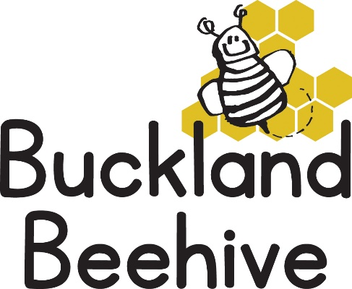
31st October 2022
Welcome back, we hope you have all had a lovely half term break. We return to a Halloween theme on Monday, with pumpkins and bats everywhere, we have jelly mixed with spiders for snack and the children will be making chocolate apples decorated with sprinkles as a treat!
Our theme this half term will be “Colours, Numbers & Shapes” so if your child would like to bring something for show and tell related to the theme, we will be making a display table especially for them.
This week we will be looking at “Shapes & Sizes” and numbers “1 & 2”, taking walks inside and outside the hall looking for shapes in our environment and finishing the week making rockets for fireworks night next weekend!
We will be welcoming Finley and Daisy who are both joining Beehive this week!
For parents of children starting school next September, there is another Open Afternoon at St. Andrews Foundation Class this Thursday from 2pm – 2.45pm. Call 853153 to book your place if you are interested.
Please remember named wellies and waterproofs, as we intend to still have our outdoor play as often as we can.
The hall telephone has been fixed, apologies for any inconvenience caused last term, if you are going to be late for collection, have a sick child or just need to contact us the number is 0560 3865484.
Many Thanks

