14th November 2022
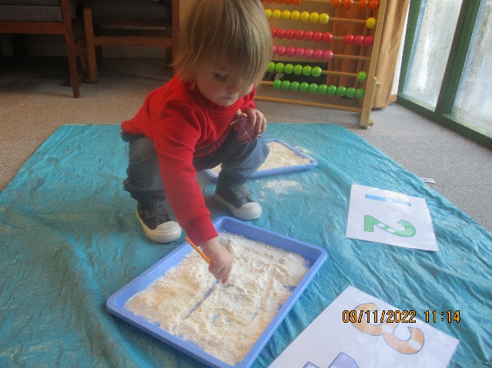
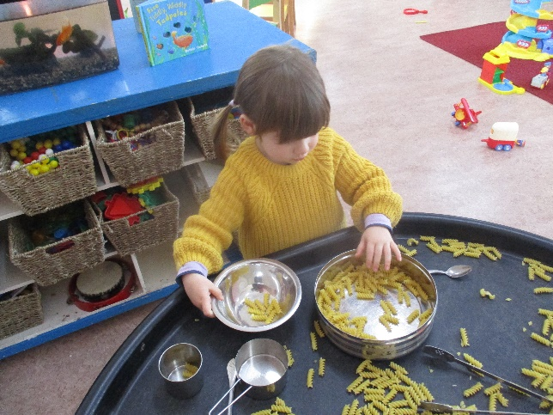
We had a great herd of Elmer elephants this week, they looked amazing, we spent the week looking at patterns, on our clothes, in our surroundings, making patterns with the toys and clapping patterns with our hands. We had pasta on our sensory table and we were mark making in flour with paint brushes, very messy!

This week we are looking at “holes and tubes” and the numbers 5 & 6. Making pictures with bubble wrap, telescopes, having the tunnels out, looking at animals that live underground, threading and much more.
On Friday 18th it is Children in Need day, so we will be wearing something spotty! Making spotty cakes, colouring spotty pictures and handing out spotty stickers to those extra good helpers of the day. You can send in a donation and I will make sure it is sent to Children in need.
Children that will be starting school in September 2023 can apply for a place at their favoured Primary School from 15th November, that is Tuesday of this week, until the 15th January 2023. It is a good idea to apply as soon as you can in order to secure your choices. You can apply online at www.devon.gov.uk/admissionsonline , I will display a poster on the main door at preschool for your information.
Many Thanks

