28th June 2021
Information for Parents
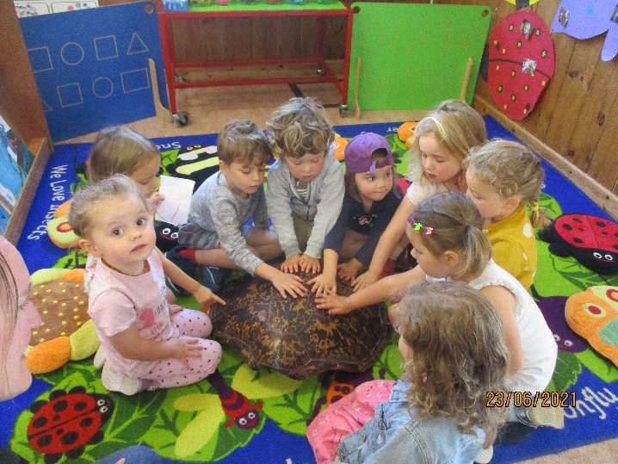
We had SAND everywhere last week, and it continues! We had some lovely shells to look and play with and Juno even bought in her Grandfathers turtle shell to show us, so we made a turtle for our picture board.
This week we are talking about transport on the sea and sea sports. We will be making boats and rafts and testing out what things can sink and float. We will also have our own made up boat to practise our role play. We will be balancing and improving our surfing skills.
Thank you for your responses to the trip to Wembury, we are still looking for three more volunteers that can join us for the day. Please let us know if you can help out.
Can you continue to put sun cream on your children before preschool, and remember their sunhats! We don’t have enough spare hats and some of the children are wearing fancy dress hats!
Again, the weather forecast for Monday is showers! So not warm enough for us to swim yet. We only have this one slot time per week and so we are very dependent on the weather.
Just a reminder, if your child is off sick or for any other reason, can you please call us on the preschool phone to let us know. This is particularly important for the voucher children as we need to record reasons for absence.

