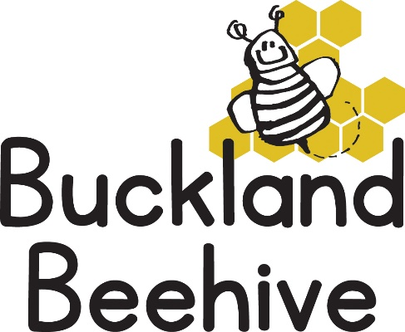
6th March 2023
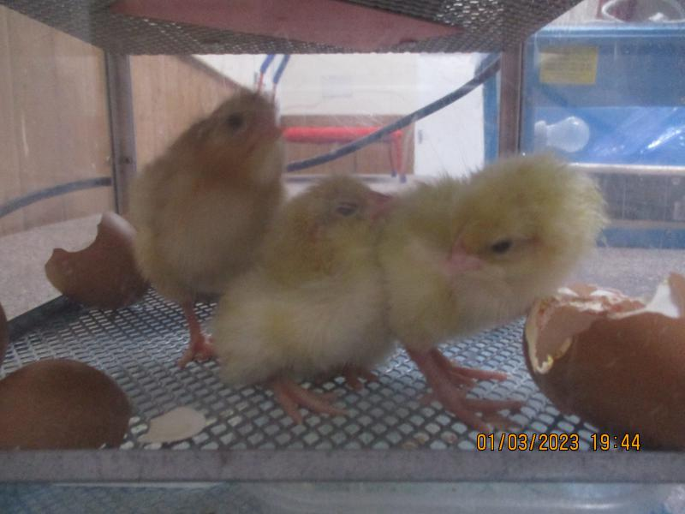
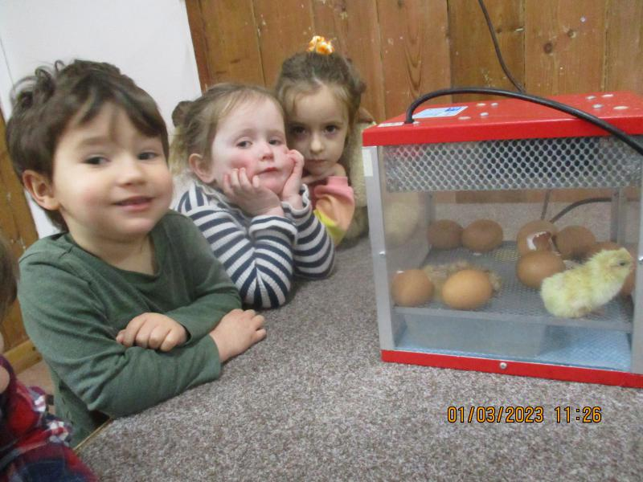
What an exciting week we had, and all 10 of our eggs hatched. Unfortunately, one chick died over the weekend, it had deformed legs and was unable to stand and feed itself, it really is the survival of the fittest. But, we still have 9 left and here you can see Thomas, Daisy and Jocelyn watching the eggs hatch in the incubator. They have all now been transferred to the Brooder box, which gives them more room and some food and water. They will stay in this until they leave on Friday.
We will be handling the chicks this week and watching them grow their adult feathers on their wings already. A really lovely experience for all of us!
This week we are looking at how things grow, we will be planting some sunflowers, which when sprouted and a young plant we will transfer to our garden at the front of the hall. We will see who grows the tallest sunflower this year! We will make paper plate sunflowers which we will display on our theme board, and hopefully if the weather is not too cold we will plant our carrots and sweet peas. Phonic letter this week is “p” , “Down the pirates plait and round his face”.
In order to help you understand the Read and Write rhymes I will attach the rhyme sheet with my email this week so you can see what we are learning.
Last week we measured all the children and made a chart, we are going to measure them again at the end of term and see if they have grown within these 6 weeks.
How did you get on with our Sponsored Listen? We recorded each day how many books we read at Beehive, and now we need to collect all your sponsorship money so we can see the total raised. Jemma, from Usborne books, is coming in on Friday to collect the total amount, and let us know how many new books we can choose for our Beehive library. Please send in all your sponsorship money raised before this Friday.

Many Thanks

