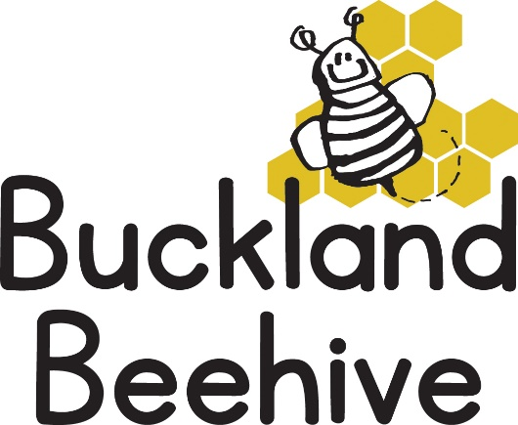

18th May 2020

Dear Parents/Carers
Today Tara, Angie, Debbie and myself have got together and discussed the possibility of reopening the Beehive on Monday 1st June as per Government guidelines announced last week. We are still waiting for clarification from the Department of Education D(of)E, as to how this phased return will work in order for us to keep your children and the staff at the Beehive as safe as possible.
In preparation we have put together a number of steps that will need to be taken and some suggestions that you as Parents will need to consider, so that you are able to make the best choice for your child/children.
- We will be welcoming the children back in phased groups, the first to return are;
The children of Keyworkers
Vulnerable or At Risk Children
Children starting school in September
- It may be that all other children could possibly return before the end of the academic school year, the situation will be monitored continuously and advice given to us by D(of)E.
- We will NOT be able to follow the 2-metre social distance rule within the preschool. Children of this age are very tactile and may need comforting at times, we can guide them but we will not be enforcing this rule.
- We will meet Parents at the door and take your child into preschool. NO parents are allowed in the hall at any time. You may arrive anytime between 8.45am and 9.15am, and please be mindful of other parents waiting to drop off their child/children.
- Your child will wash their hands on arrival and we will sign them in and settle them ready for the session.
- We will not be encouraging Show and Tell as this entails toys being bought in from home, when we do have group time, we will space the bug cushions further apart to avoid unnecessary close contact.
- We will have limited resources, there will be no soft toys, playdough or sand available, we aim to keep our setting as safe as possible and this requires us to disinfect all equipment daily at the end of the session.
- We will aim to use the garden as much as possible, encouraging free play between inside and outdoors during good weather.
- A member of Staff will prepare the snack and divide it amongst the plates prior to the children being seated, drinks will already be poured. The children will be equally spaced around the tables, this applies at lunchtime as well.
- We will continue to encourage good hygiene and wash our hands regularly.
- At home time parents may arrive anytime between 12.30 and 1pm on a Monday, Wednesday and Thursday, and between 2.45 and 3pm on a Tuesday and Friday to collect their child/children, again we will meet you at the door with your child ready to go home with their bag and lunchbox.
- We will NOT be able to accept any child into the setting that has a temperature or a cough, regardless of the reasons and children that develop a cough or temperature at the setting will have to be collected immediately.
These are just some of the measures that we have had to consider and I felt it important that you all were aware of what we have been discussing and how we were going to ensure that we have the safest possible environment for your children to return to. The village hall has been deep cleaned over the last few weeks, and we have cleaned all the preschool equipment in readiness for the 1st of June.
I have also been in touch with Mrs Murdoch the Foundation teacher from St. Andrews School, and she informs me that at this time NO transition sessions will be taking place. This may change, but it is disappointing for our children that will be starting school in September.
Please also keep in mind that we will only reopen providing that the 5 key tests set by the Government are met, and that the rate of infection continues to decrease. If these criteria are not met then the opening of schools, preschools and Nurseries will be delayed.
If you choose not to send your child back until September, we totally understand. You will not be charged preschool fees and we will keep your child’s space available from September.
I will need to know by the end of this week if you intend your child to return to preschool on the 1st of June, this will give me an idea of how many children to expect and assist us with planning and staffing levels. You do not need to justify your reasons, every parent’s situation is different and I understand that, but I will need to know so I can put our plans into place.
You may have a number of questions and I will do my best to answer them if possible. It takes time to read through the Government guidelines so please be patient!
Kind Regards
Jane

