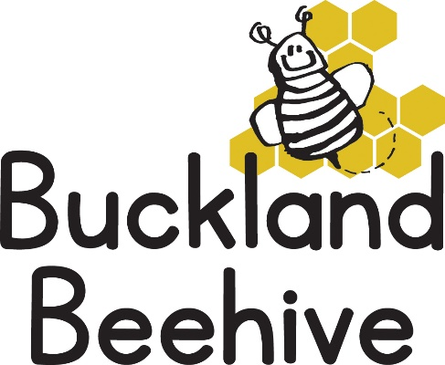
4th July 2022
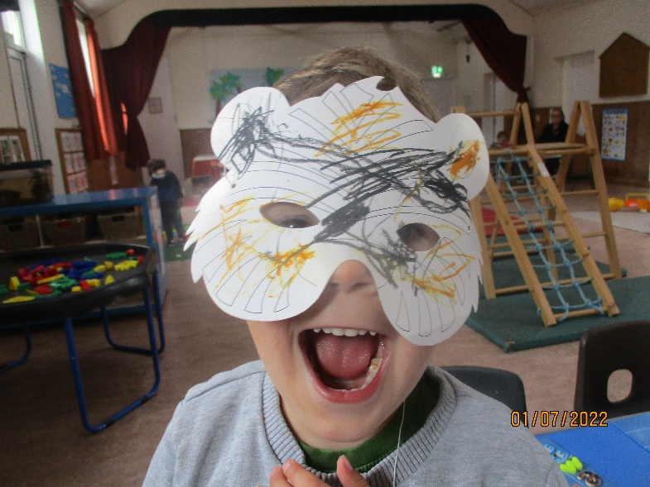
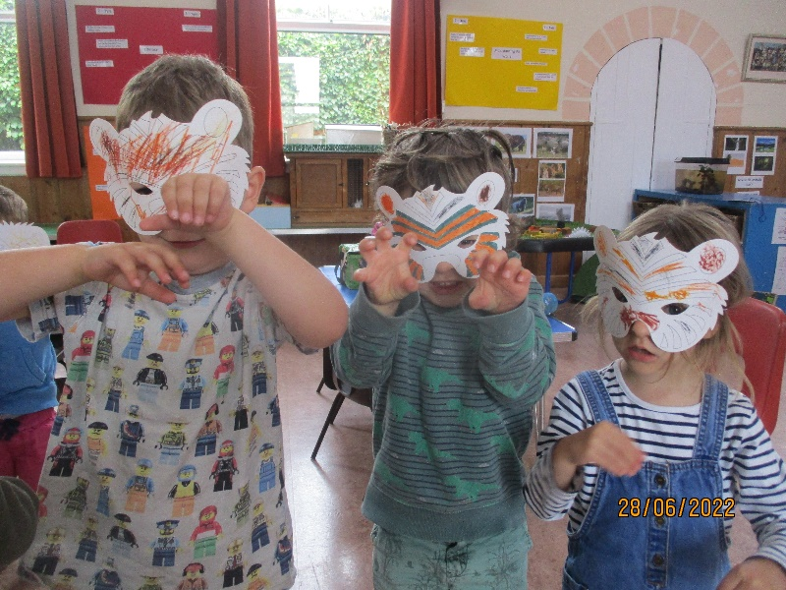
Information for Parents
Great animal masks this week, we had lots of cuddly animals for show and tell as well and we learnt all about baby animals, their names and some children were able to take a walk to the local farm to see the calves.
We continue our theme this week by concentrating on farm animals, and who looks after them? Making cow craft and adding to our theme board. We will also be celebrating Will’s third birthday this week!
On Friday 8th, it is our Sports event! Drop off the children as normal at 9am and we will take them into the side room until we are ready to start at 9.15am. Everyone is welcome, it is a very relaxed session where the children do various races up and down the hall to wild applause!! We then present them all with a medal before we arrange snack and return to a normal session again. It usually lasts about half an hour. Children who are not normally booked in on a Friday are still welcome to join in the races and they can leave with you afterwards. Any questions, please ask or email me.
Can I remind the parents of children starting school in September, that there are two transition afternoons organised by the school on Monday 11th @ 1.30 – 3pm and Monday 18th @ 1.30 – 3pm. Please can you let us know if your child will be collected early from Beehive on those days.
I now have enough parents that have volunteered for the Dartmoor Zoo trip, so thank you. I carried out a risk assessment on Saturday and I think we will have a lovely time. I still need to hear back from some of you as to whether your child is attending or not. Can you make sure you return your consent slip as soon as possible.

Many Thanks

