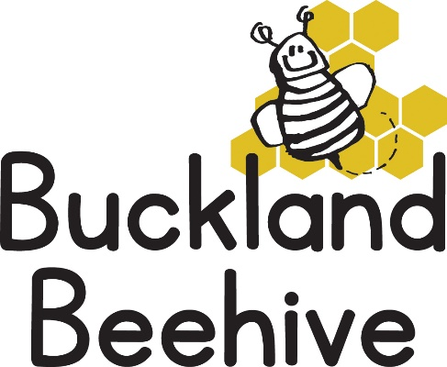

8th September 2020
Information for Parents
Welcome back to the Beehive! It is such a relief to us all that we can try and resume some sort of normality at last. We are very much looking forward to welcoming your children back into preschool. We have three new children starting, Barney, Christopher and Skylar and we are very excited to include them in our busy sessions.
This terms theme is “All about Us”, we are going to find out all we can about each other, what we look like, where we live, what we eat, how to keep healthy, our skeletons and much, much more. In our first week though, we will start with a very relaxed few days just getting to know each other, the routine, meeting the pets and just having a fun time.
We do still have some restrictions in place as a result of Covid, for instance we have to restrict the amount of adults entering the hall, so for the time being we will meet you at the door and your child can come in and we will book them in for you. The same with going home, if you wait outside the hall, we will bring your child out to you. Whilst waiting outside, please remember to social distance yourself from other parents.
Please remember to bring your child’s wellies! We do try and play outside as much as possible and the ground is already starting to get muddy!
If you have any questions please speak to Tara, Angie, Debbie or myself.
Many Thanks

