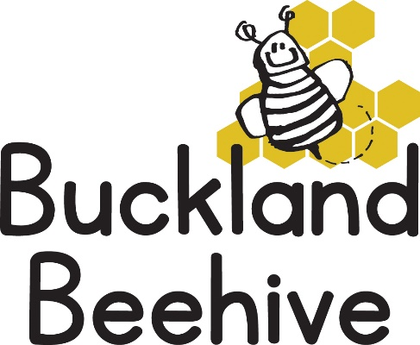
22nd November 2021
Information for Parents
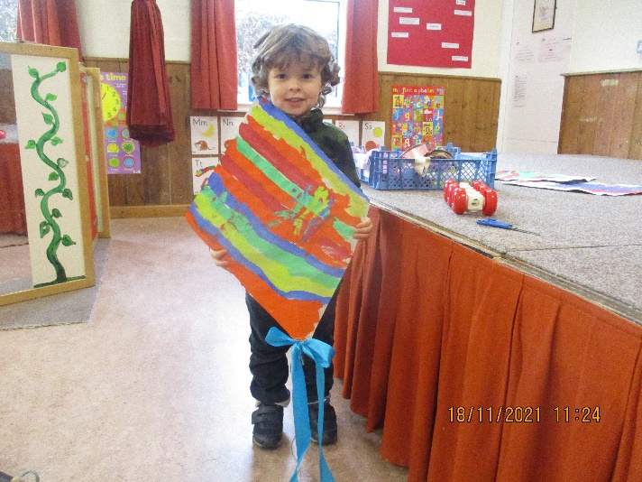
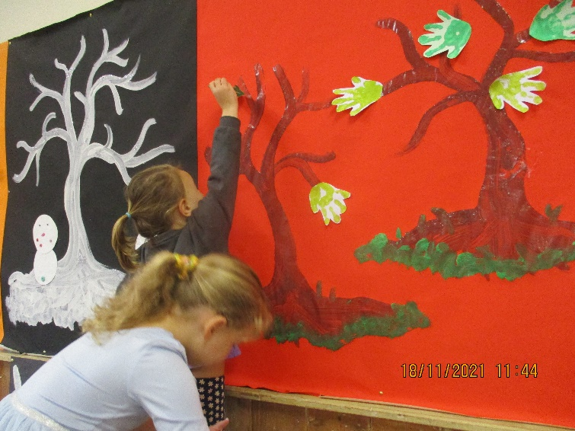
It did feel a bit Spring like last week, not cold but a bit damp! Just right for us to plant some Snowdrops for next year in the planters at the front of the hall. The children made some great kites for flying in the wind, and I had some good helpers to stick blossom on our Theme board. The children also coloured some wind chimes and we finished the week by making spotty fairy cakes for Children in Need.
We can complete our display this week when we talk all about the Summer season and Rainbows. We will also be making some flowerpot brownies, which are delicious so they may not make it home! As well as setting up our Travel Agent shop, wouldn’t that be lovely to jet away to some sunshine!
There are a lot of colds, runny noses and coughs at the moment. We are encouraging the children to wipe their noses and wash their hands, cover their mouths when coughing and not to pick their noses!! And we have also had a number of children with conjunctivitis. Cooled salted boiled water, bathed on the eyes is helpful, but please if your child has sticky eyes, take them to the doctor for treatment as it is highly contagious. We have had at least five cases, we are continuing to disinfect the equipment as best we can and to practise good hygiene, but this needs to continue at home as well in order to get the children to remember to keep washing their hands to clean the bugs away.
Just a reminder that on Monday and Wednesday this week, please collect your children from the side entrance as other groups are using the main hall.
Many Thanks

