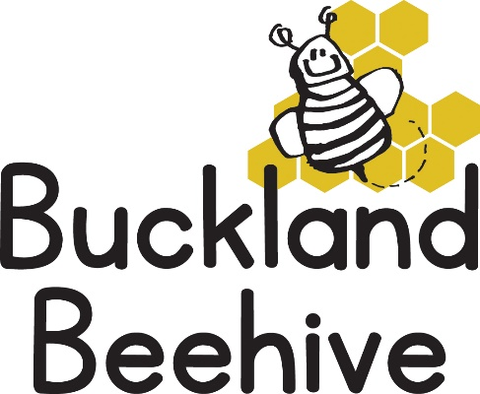
24th February 2020
Information for Parents
Welcome back, we hope you all had a lovely week even though the weather was so miserable!
This half term is only five weeks long before we have our Easter break so we have a lot to pack in during that time. Our theme is Minibeasts and we start off looking at Beetles, making crafts and there is bound to be lots of searching in the undergrowth when we go outside. Luckily, we also have Pancake Day on Tuesday as well as two birthdays this week so we will be eating lots of treats!
We welcome Verity Bowden to the Beehive on Friday; she will be starting now she is two years old alongside her brother Thomas. Also, Claire Wingfield, who some of you may know as Timothy’s mum, would like to join us as a Volunteer helper on a Monday, Tuesday and Wednesday. All security checks have been carried out and her induction begins on Monday morning. We are very much looking forward to her joining our team and will relish another pair of hands to help with the activities planned for the children.
If you would like to see your child’s scrapbook or discuss your child’s developmental progress, please take this opportunity to talk to your child’s keyworker. There is only five months left of this school year and after Easter we will be preparing the children that are starting school in September for their big move. Weekly visits to Foundation will take place, which I will confirm with Bex Murdoch and let you all know.

Many Thanks

