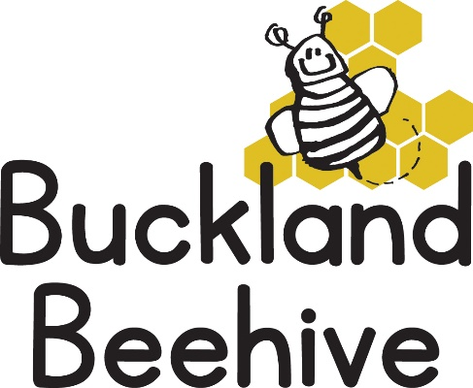
8th May 2022
Information for Parents
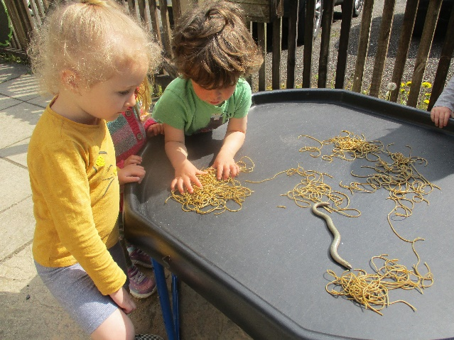
Whilst learning about worms, snails and caterpillars, Debbie found a slowworm in the garden, the children all thought it was a snake! Perfectly harmless, but with a forked tongue!
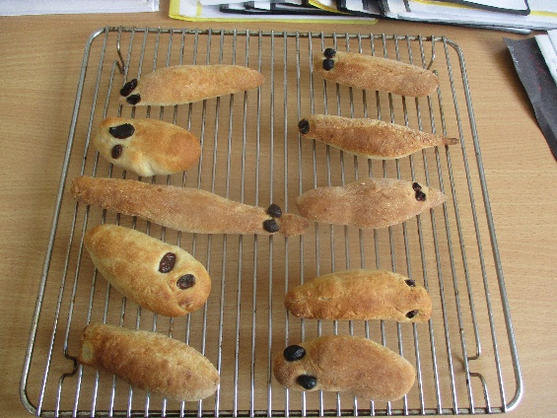
Our bread snails turned into worms as this was the easiest shape for the children to make, not sure what they would taste like, they seemed pretty hard! Our caterpillars continue to grow, we think they may make their chrysalis over the weekend.
This week we are Humming and Buzzing like bees. We will have honey on toast for snack, make bee handprints and beautiful paper plate flowers for craft. Angie bought in a piece of honeycomb from a hive for us to look at and our shape of the week is therefore obviously a Hexagon, that’s a hard one for show and tell!
Just a reminder, could you remember your child’s yellow book bag to bring to preschool, we always write in their yellow books once a week and it helps us to send messages home and a library book, sometimes it is not always easy to think of things when it is busy at going home time.
It looks like the transition day from Beehive for the children who will be starting school in September will be Wednesday afternoon. Two members of staff will take the children to school for an hour every Wednesday after half term. I am waiting for confirmation from Mrs Murdoch, there are also two transition days set by the school on Monday 11th and Monday 18th July, 1.30pm until 3pm. Please can you let us know if you are collecting your child early from Beehive that day.
Our swimming sessions on a Monday morning, will probably commence after half term. Hope fully by then the weather would have improved and the pool will be warm enough for us. It has to be a positive experience for everyone, so the conditions need to be right before we go. We will let you know via Facebook and email if it going ahead beforehand.
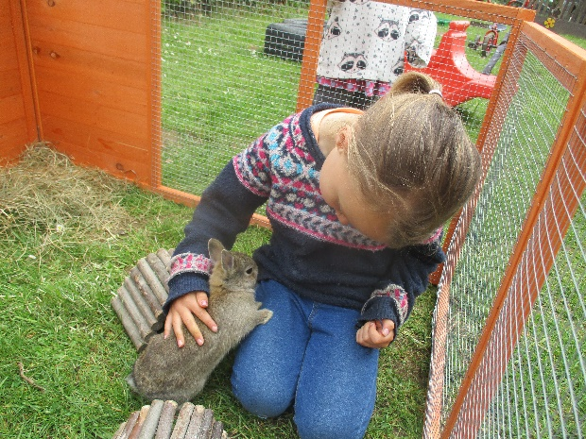
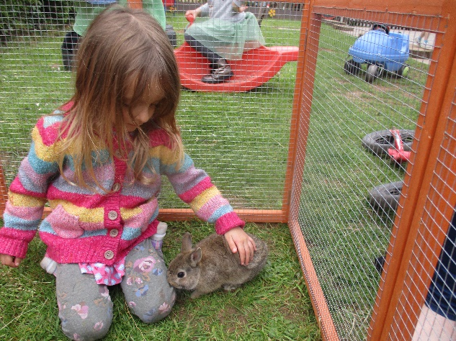
Tara decided to give the children an up close and personal experience with Peter & Whiskers this week by actually putting them in the run. The bunnies are too skittish to put them on the children’s laps, but this way the rabbits can approach them when they like. The children really enjoyed it and I think it will be a regular event from now on.

Beki, Will’s Mum, has taken some superb photographs of some of the children and uploaded them onto her website for you all to take a look. She is returning on Tuesday and Friday of this week to take more photos of the remaining children and some group photos with Staff as well.
The photos are very candid and of the moment, she can do them in colour or black & white depending on what you prefer.
Her website is www.JetDeanPhotography.com on the headings click on More and there is an option for Buckland Beehive 2022, click on that and you have to put in a password of beehive2022 to access the photos. Details of the cost and how to pay are all on the webpage.
You may want to wait until all the photos have been uploaded including the Group photos, but I thought you may want a sneaky peak of what she has done so far.
I always wanted to set up some photographs of the children for you all, and wanted to steer clear of the formal style of Tempest, which you will experience at School, Beki has certainly done that and produced some outstanding snapshots of your children at Beehive which I hope you love as much as I do. She is equally as excited as this is a first experience for her too, she is also available for individual photoshoots so it is worth taking a look at her website to see the extent of what she can offer.

Many Thanks

