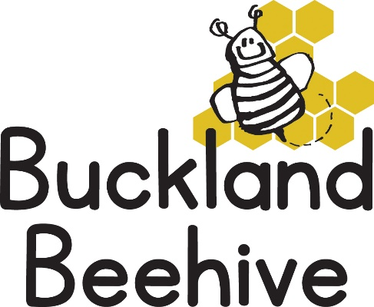
21st November 2022
We had a very depleted Preschool last week with so many of the children off sick with the coughing bug and colds. I hope they have all recovered for this week as we will be starting to practise our songs for the Christmas Show! We have decided that because we have so many young children this year we will be singing a combination of nursery rhymes and Christmas songs. I will send you all a copy of the songs we have decided to include so that you can practise them at home, especially as some of our children only attend for one session a week!
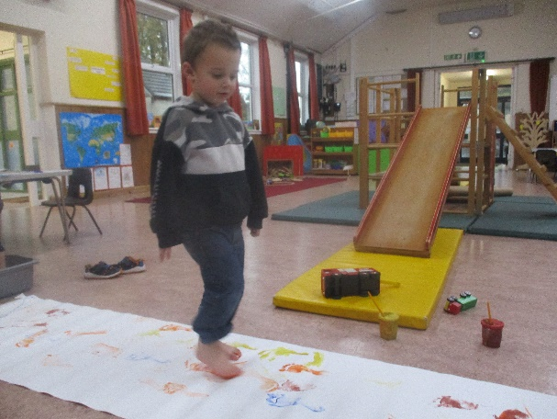
We did manage to have some fun activities last week, foot printing was a huge success and very messy! And we made some spotty cakes for children in need day on Friday
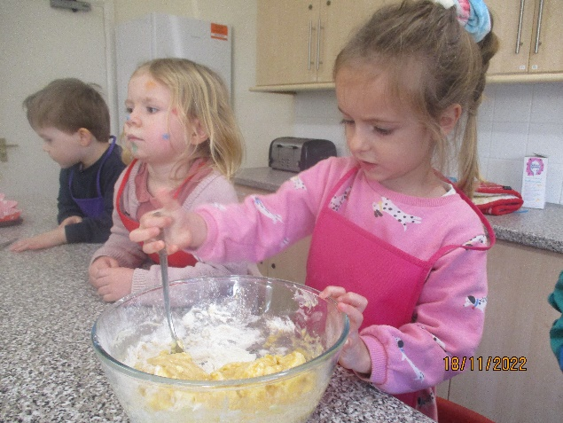

We made bubble wrap fish and they practised threading skills using the letter of their name. Some of these crafts we will keep for their scrapbooks.
This week we are looking at the colours Yellow and Red. We will be making bright sunflowers, trying lots of red and yellow foods at snack time, and mixing colours to see what other colours we can make, we will be reading “Little Red Riding Hood” and playing with the dressing up clothes as well as looking at number 6 again and finding bugs with six legs!
If your child would like to bring something for show and tell, maybe it could be something that is yellow or red and we will set up a display table for the week.
We are still needing to collect soft toys for our Tombola at the Christmas Fair, if you have any spare, please send them in, thanks.
As the weather continues to get colder, we still try and get outside as much as we can, so hats and gloves may be needed soon, if you can name them it makes it so much easier for us and less likely that they get lost.
I continue to post the weekly photos on our website, if you need the password to gain access to the photos, please ask Tara, Angie, Debbie or myself.

Many Thanks

